Assignment 4: Cryptography

1. What Is Bitcoin

Bitcoin was created in 2008 when an unknown entity published a white paper, using the name Satoshi Nakamoto. Bitcoin is a digital money system. It is a decentralized cryptocurrency, meaning people can send and receive value directly with each other (peer to peer) without using banks or payment apps.

2. Bitcoin Monitoring policy

The purpose of this Bitcoin Monitoring Policy is to establish guidelines for tracking Bitcoin transactions, wallet activities, price movements, and potential suspicious behavior. This ensures transparency, security, and compliance with regulatory standards.

3. Mining

Bitcoin mining is the process through which new bitcoins are created and transactions are verified and added to the blockchain.
Miners use powerful computers to solve complex mathematical puzzles.
The first miner to solve the puzzle gets to:
✔ validate a block of transactions
✔ add it to the blockchain
✔ receive a block reward (new bitcoins + transaction fees)

Why Mining Is Needed
Mining performs three core functions:

1. Secures the network
The puzzle is difficult, so an attacker would need huge computing power to change transaction history.

2. Validates transactions
Only valid transactions get added to the blockchain.

How Bitcoin Mining Works (Simplified)

Step 1: Transactions occur
People send BTC to each other.

Step 2: Miners collect transactions
They place them into a block waiting to be verified.

Step 3: Miners solve a puzzle
They must find a value (nonce) that makes the block’s hash meet the difficulty target.

Step 4: Winner adds the block to the blockchain
The first miner to solve the puzzle broadcasts the block to the network.

Step 5: Miner earns a reward
They get:
- Newly created bitcoins (block reward)
- Transaction fees
4. Nonce

What is a Nonce in Blockchain?
A nonce (short for Number Only Used Once) is a random number that miners change repeatedly to find a valid hash for a block.
It is the variable miners adjust thousands of times per second to solve the Proof-of-Work puzzle.
Imagine a lock that opens only if you enter a number starting with “0000…”.
You keep trying different numbers again and again.
That number you keep changing = nonce.

5. CPU, GPU And ASIC (Hardware)

1. CPU (Central Processing Unit)

The main processor in a computer.
Used in the early days of Bitcoin, but now too slow and inefficient.
2. GPU (Graphics Processing Unit)
A graphics card used primarily for gaming and video rendering.
Better than CPUs, but still not strong enough for Bitcoin mining today.

3. ASIC (Application-Specific Integrated Circuit)
A special machine built only for mining a specific algorithm (e.g., SHA-256 for Bitcoin).

In One Line Each
- CPU: General-purpose processor, slow for mining.
- GPU: Parallel processor, good for many coins, once used for ETH.
- ASIC: Mining-only machine, extremely fast, used for Bitcoin

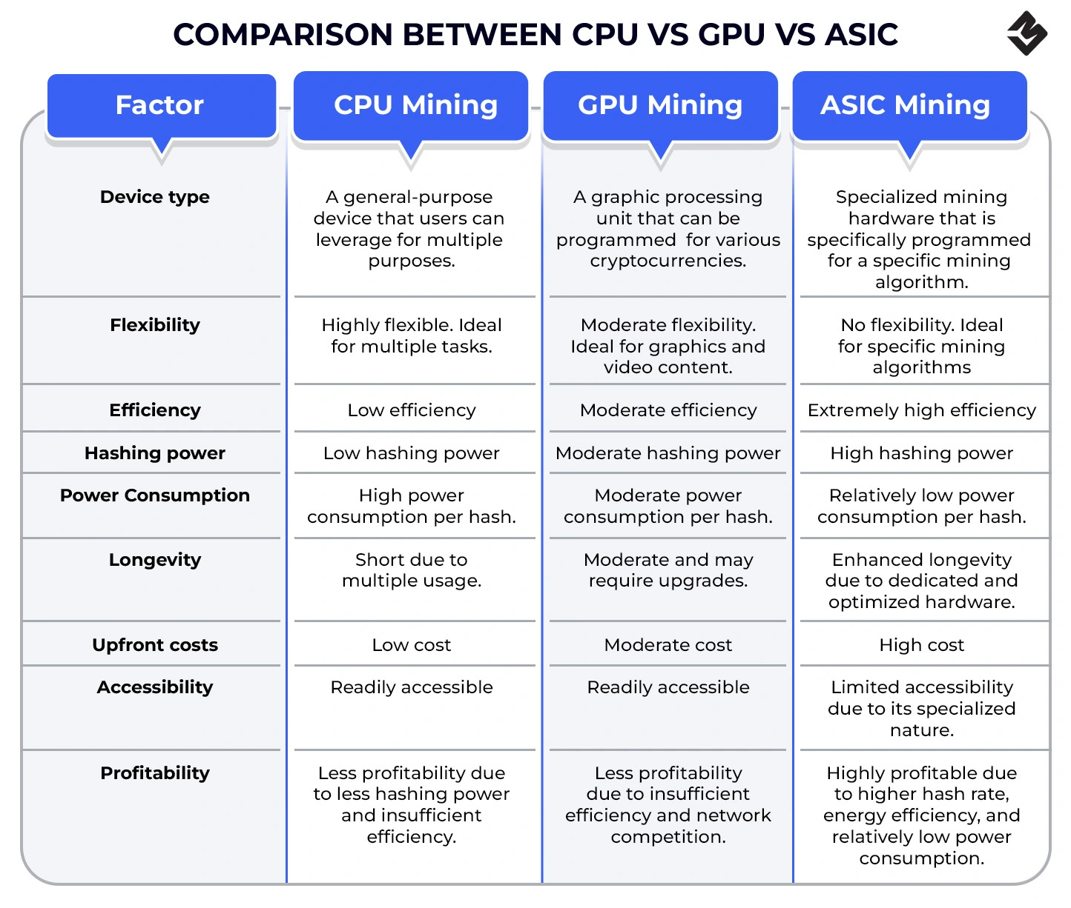
6. Mempool

Bitcoin Mempool Overview
The mempool (short for memory pool), is a “waiting room” for unprocessed Bitcoin transactions. Bitcoin miners will select transactions from this pool to include in the next Bitcoin block, with preference given to those with higher fees. Mempool is also sometimes confused with the popular Bitcoin block explorer mempool.space, which is simply named after Bitcoin's transaction pool.
- Each Bitcoin node (network operator) maintains its own mempool, meaning different computers in the network may have slightly different collections of pending transactions.
- Transaction fees determine priority—miners typically select transactions with higher fees first to maximize their profits.
- You can monitor mempool activity using tools like mempool.space to optimize your transaction timing and fees.

7. Transaction
A Bitcoin transaction is a digital message that transfers BTC from one person (or wallet) to another.
It uses cryptography to prove ownership and prevent fraud.
Every transaction includes:
- Inputs (where your Bitcoin comes from)
- Outputs (where the Bitcoin is going)
- Amount sent
- Miner fee
- Digital signature (proof you own the BTC)
After a transaction is created, it goes to the mempool, then miners add it to a block, and finally it becomes part of the Bitcoin blockchain.
8. Wallet
A wallet stores your private keys safely. It helps you send, receive, and view cryptocurrency. There are mobile, hardware, and online wallets.
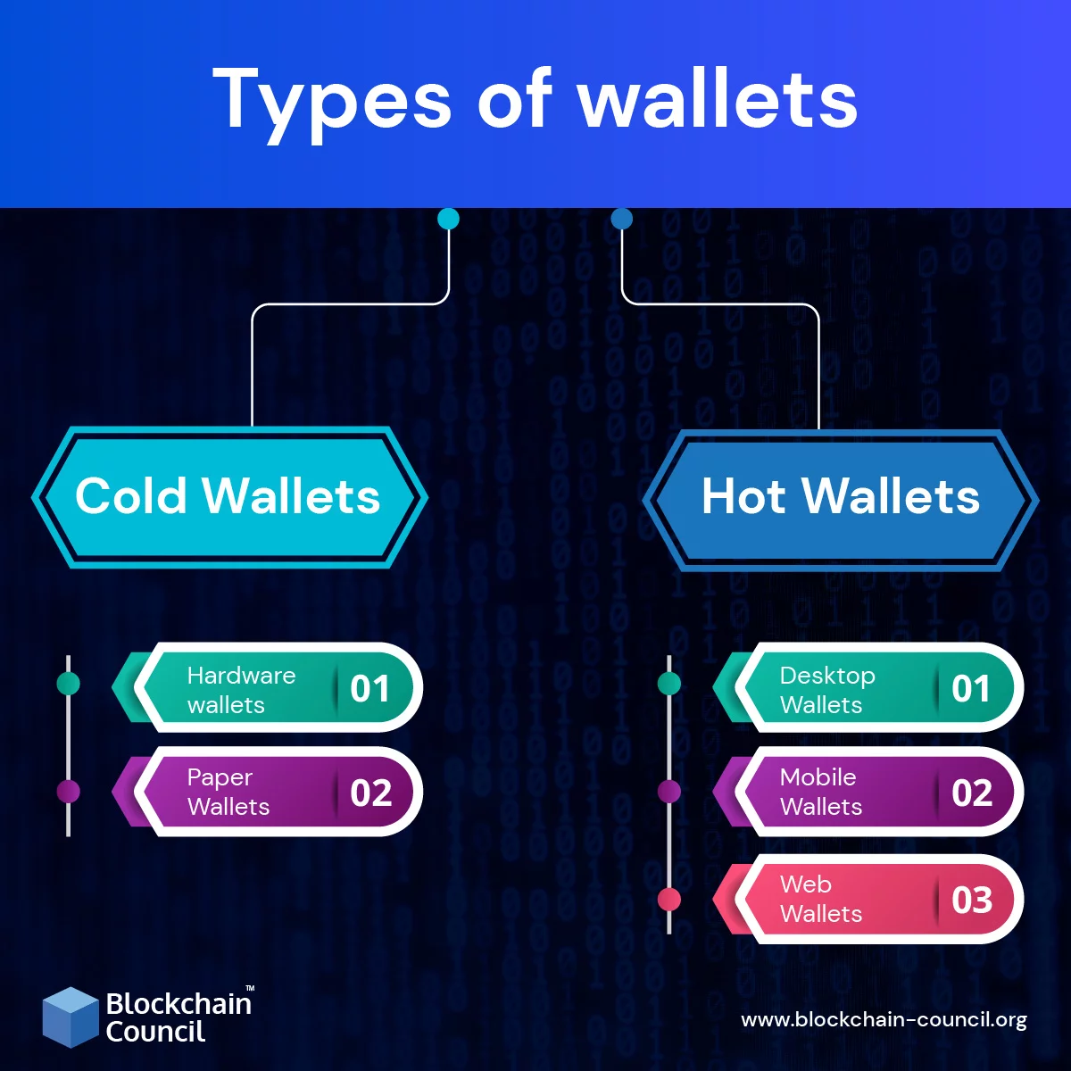

9. Public and private key
In blockchain (Bitcoin, Ethereum, etc.), public and private keys work together like a secure digital lock-and-key system.
They are mathematically linked, but you can share the public key with anyone, while the private key must be kept secret.

In One Line
Public key = your receiving address
Private key = your access + spending power

How They Work Together (Simple Flow)
- You generate a private key.
- From the private key, the system mathematically creates a public key.
- A wallet address is derived from the public key (shorter and easier to share).
  - Public key = lets people send you crypto
  - Private key = lets you spend the crypto

Example
Suppose Alice wants to send Bitcoin to Bob:
- Bob gives Alice his public key/wallet address
- Alice sends BTC to that public address
- To spend that BTC, Bob must use his private key
- The network verifies Bob's ownership using his public key

